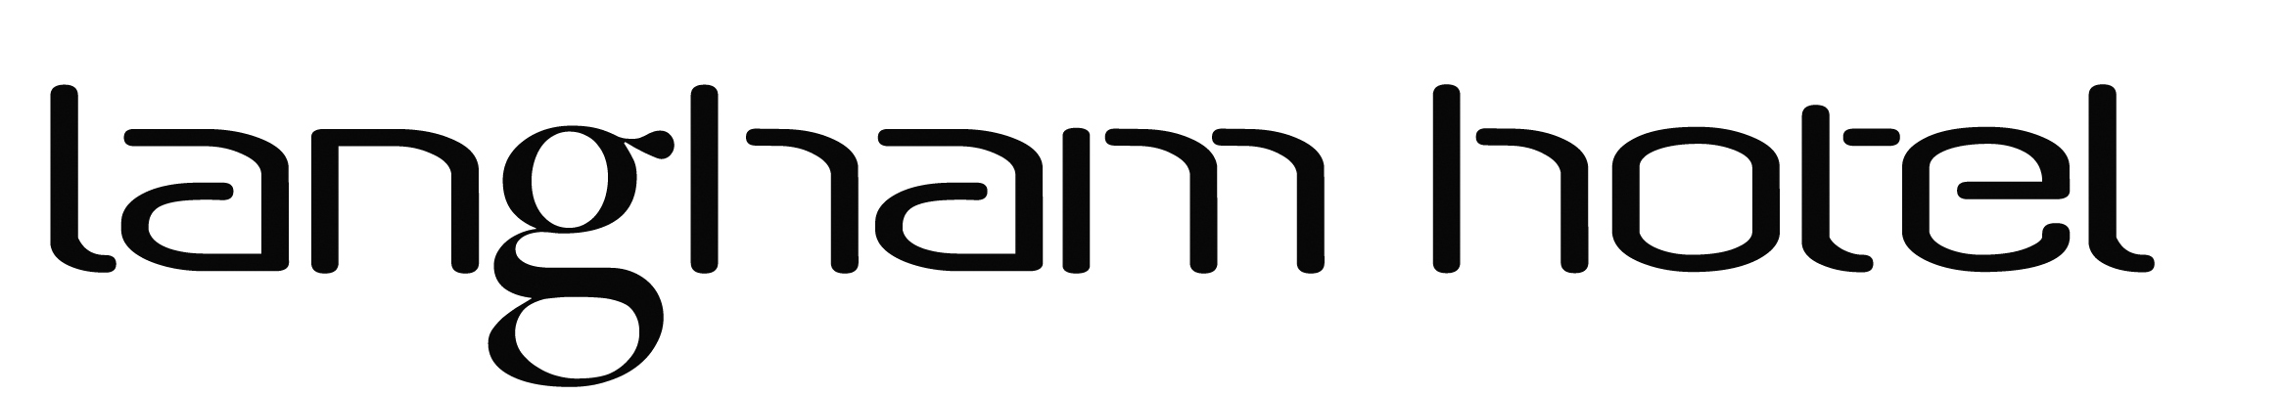

Meetings at the Langham 2023

We are delighted that you are considering using the Langham Hotel to host your meeting.

Our Meeting facilities are as follows:

The West Dean Suite with over 1200 feet of meeting space accommodating 70 delegates theatre style or up to 20 delegates Boardroom style or U Shape. This room also hosts a private lounge facility.

The Sovereign Suite seats up to 12 delegates boardroom style and up to 30 people theatre style. (U shape is not available) This suite also hosts a 42 inch HD TV.

Meeting Rooms & Equipment Price (Ex VAT)

- West Dean Suite (9am to 530pm or ½ day) 195.00 (120.00)
- Sovereign suite (9am to 530pm or ½ day) 125.00 (90.00)
- Flipchart, Screen, Pads & Pencils 0.00
- Projector 0.00

Refreshments

- Tea & coffee and biscuits/flapjack 3.75 per person
- Bacon or Sausage Rolls 6.50 per person
- Croissants & Danish Pastries 5.50 per person
- 2 course Restaurant lunch 25.00 per person
- 3 course Restaurant lunch 35.00 per person
- Traditional Working buffet lunch 26.00 per person
- Sandwich selection and Chips 11.00 per person
- Still or Sparkling bottled Mineral Water 4.75 per bottle

Office Services ______

- WIFI access 0.00
- Black & White Photocopying/printing 0.15 per page
- Colour Photocopying/printing 0.25 per page
- Word Processing 3.00 per page

Day Delegate Rate £60 per person (minimum 15 people)__________________________

- Room Hire & Equipment for 1 day
- Bottled Mineral Water
- Tea, Coffee, Orange juice and Danish pastries and Croissants on arrival
- Tea, Coffee and Flapjack mid-morning
- Two course Lunch or Working buffet
- Tea, Coffee and Cake in the Afternoon

A 24hr delegate package is also available upon request.

